 **Year 7 – Humanities and Social Sciences**

**Assessment 3 - PART A 5% & PART B 5%**

**Inquiry Task**

**A significant individual in an ancient society**

**Name: _______________________________**

|  |  |  |  |
| --- | --- | --- | --- |
| **Your Target** | **Mark** | **Percentage** | **Weighting** |
| **Museum**  **Display**  **/20**  **Inquiry Process**  **/57** | **Museum**  **Display**  **/20**  **Inquiry Process**  **/57** |  | **5%**  **5%** |

**Date Due: Week 9, Term 3.**

**_____________________**

**Section One (PART A): Inquiry Process**

Investigate the life of a significant individual in an ancient society. Steps to follow:

1. 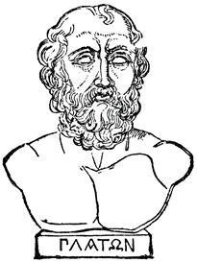Choose one individual from the list provided.
2. 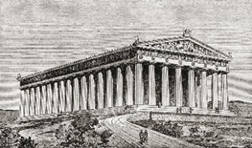Use the inquiry booklet to come up with 5 focus questions and then record your information, including the KWL Chart
3. You will have five lessons to complete research using the internet and books
4. 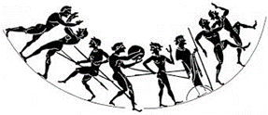Lastly, remember to include a bibliography. A range of references must be used.
5. Complete the PMI Chart. This is to evaluate the task.
6. *Make sure that your research focuses on what must be included in your museum display (list provided below).*

**Section Two (PART B): Constructing the museum display**

**(Inquiry Task – Communicating and Reflecting)**

Present your findings from Part A as a museum display. You will have four lessons in class to construct your display, using your inquiry booklet. Plus, you can (and should!) work on this task for homework.

**The museum display must include information about:**

* The background of the significant individual (family background, early influences)
* The career of the significant individual (key events in their lives, methods used to achieve aims, relationships with other individuals and groups)
* Challenges to the individual presented by others
* The manner and impact of their death
* The legacy of the significant individual (assessment of their life and career, ways they shaped or changed their society, their long-term impact and legacy).

1. **Choose a significant individual from the following list below:**

* Hipocrates
* Thales of Miletus
* Phidias
* Solon
* Democritus
* Herodotus
* Leonidas I
* Archimedes
* Pythagoras
* Pericles
* Plato
* Aristotle
* Homer
* Socrates
* Alexander the Great

Other - _________________________________ (Must be negotiated with your HASS teacher. If you have an idea please ask your HASS teacher. It must relate to your depth study).

**Inquiry Process Booklet**

Teacher to tick when completed

Date:­­

Teacher Initial:

Which significant individual did you choose for this inquiry?

________________________________________________________

What do I already know about the topic?

1. **Complete the brainstorm below, focusing on what you know about your ancient civilisation.**

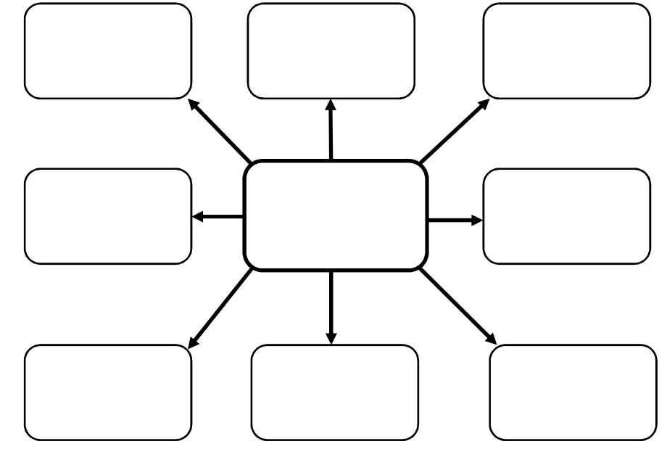

Teacher to tick when completed

Date:­­

Teacher Initial:

**Complete the KWL below on your chosen individual;**

|  |  |  |
| --- | --- | --- |
| K | W | L |
| What do you already **know** about the topic? | What do you **want** to know about the topic? | What have you **learned** about the topic? |
|  |  | Teacher to tick when completed  Date:­­  Teacher Initial: |

1. **Note taking sheet**

**Focus Question 1**

|  |
| --- |
|  |

**Key points from information sources and reference details**

|  |
| --- |
|  |

Teacher to tick when completed

Date:­­

Teacher Initial:

**Focus Question 2**

|  |
| --- |
|  |

|  |
| --- |
| **Key points from information sources and reference details** |

Teacher to tick when completed

Date:­­

Teacher Initial:

**Focus Question 3**

|  |
| --- |
|  |

**Key points from information sources and reference details**

|  |
| --- |
|  |

Teacher to tick when completed

Date:­­

Teacher Initial:

**Focus Question 4**

|  |
| --- |
|  |

**Key points from information sources and reference details**

|  |
| --- |
|  |

Teacher to tick when completed

Date:­­

Teacher Initial:

**Focus Question 5**

|  |
| --- |
|  |

**Key points from information sources and reference details**

|  |
| --- |
| Topic: |

Teacher to tick when completed

Date:­­

Teacher Initial:

1. **Complete the PMI chart below (THE TASK)**

|  |  |  |
| --- | --- | --- |
| P – Plus | M - Minus | I - Interesting |
| Positives (Pluses) about the task | Negatives (Minuses) about the task | Interesting parts of the task |
|  |  |  |

Teacher to tick when completed

Date:­­

Teacher Initial:

|  |  |  |  |  |  |
| --- | --- | --- | --- | --- | --- |
| **Author** | **Date last updated** | **Title of Webpage** | **Date accessed** | **HTTP** | |
|  |  |  |  |  | |
|  |  |  |  |  | |
|  |  |  |  |  | |
|  |  |  |  |  | |
|  |  |  |  |  | |
|  |  |  |  |  | |
| **Author** | **Date of Publication** | **Title of Book** | **Publisher** | | **Place of Publication** |
|  |  |  |  | |  |
|  |  |  |  | |  |
|  |  |  |  | |  |

1. **Reference recording sheet**

*Please note that in order to obtain full marks you must submit a formal bibliography, the table below is only for recording your references as you are researching.*

Teacher to tick when completed

Date:­­

Teacher Initial:

Teacher to tick when completed

Date:­­

Teacher Initial:

Teacher to tick when completed

Date:­­

Teacher Initial:

Teacher to tick when completed

Date:­­

Teacher Initial:

Teacher to tick when completed

Date:­­

Teacher Initial:

Teacher to tick when completed

Date:­­

Teacher Initial:

Teacher to tick when completed

Date:­­

Teacher Initial:

Name: __________________________ *My Target: _________ / or ________ %*

**PLEASE SUBMIT THIS SHEET WITH YOUR NOTES ON THE DUE DATE!**

Assessment 2 Part A– Inquiry Process (5%)

DETAILED MARKING GUIDE/RUBRIC

|  |  |  |  |  |  |
| --- | --- | --- | --- | --- | --- |
| **Task 🡫 &**  **Marks Allocation 🡪** |  | **5 - 6** | **3 – 4** | **0 - 2** | **Subtotal** |
| **Brainstorm** |  | Clear evidence of brainstorming of ideas for the product and the task. Comprehensive detail and a wide range of ideas is included. | Some evidence of brainstorming of ideas for the product and the task. Some detail is included and a range of ideas is included. | Little evidence of brainstorming ideas about the product or the task. Lacks detail and range of ideas. |  |
| **KWL** |  | Comprehensive detail is used in each section of the KWL, which relates clearly to the chosen significant individual. Has included detailed and well thought-out possible focus questions. | Detail has been used in most sections of the KWL and information mostly relates to the significant individual. Has included possible focus questions however some may be lacking in detail. | Little or no detail has been used in all sections of the KWL and it may not relate to the significant individual. Has not included suitable focus questions. |  |
| **Focus questions** |  | Devises a set of focus questions which clearly address the information required for the museum display. | Devises a set of simple questions which identifies some information needed for the museum display. | Lists a few simple questions which identify limited information needed for the museum display. |  |
|  | **20 -25** | **14 - 19** | **8 - 13** | **0 - 7** |  |
| **Note taking** | Provides very detailed, comprehensive and accurate notes. Notes address research areas in detail.  Uses evidence from a range of relevant sources. | Provides detailed and mostly accurate notes which address the research areas.  Uses evidence from a range of sources which are mostly relevant. | Provides notes of adequate detail which attempt to address the research areas.  Uses evidence from a few sources which are somewhat relevant. | Notes are limited in detail and do not address the research detail.  Uses little evidence from limited sources which have little or no relevance.  No notes are submitted (0) |  |
|  |  | **5 - 6** | **3 – 4** | **0 - 2** |  |
| **PMI Chart** |  | Presents a very detailed and comprehensive chart, through the use of a well-structured PMI Chart. Comprehensive detail is used in each section of the PMI chart, which relates clearly to the task and the key areas. Includes detail on task and topic. | Presents a less detailed PMI chart. Less comprehensive reference to key areas. Some sections are incomplete or the chart is not finished, with sections missing, including basic information on task and/or topic. | Presents a generalised plan and/or limited chart. Limited references are made to key areas. Sections are missed.  No KWL Chart is submitted (0) |  |
|  |  | **6 – 8** | **3 - 5** | **0 - 2** |  |
| **Bibliography** |  | Submits a formal bibliography which collects information from a comprehensive number of sources incorporating ethical protocols which correctly follow the referencing technique approved by the school. | Submits a formal bibliography that includes a smaller range of sources which mostly follow the referencing technique approved by the school.  Has used a variety of sources however has only recorded these in the reference recording sheet (3) | Bibliography includes a limited list of sources which may follow the referencing technique approved by the school. |  |
|  | |  |  | **Task 2 Part A - TOTAL** | **/57** |

Assessment 2 Part B– Museum Display (5%)

**DETAILED MARKING GUIDE/RUBRIC**

|  |  |  |  |  |  |
| --- | --- | --- | --- | --- | --- |
| **Task 🡫 &**  **Marks Allocation**  **🡪** | **3** | **2** | **1** | 1. **- 0.5** | **Subtotal** |
| **Background** | Provides a very detailed description on the background of the chosen individual. The description includes all of the following areas; date of birth, place of birth, parents and early influences. Includes supporting evidence and examples. | Provides a somewhat detailed description on the background of the chosen individual. The description includes information on most of the following areas; date of birth, place of birth, parents and early influences. | Has briefly outlined the background of the chosen individual. The description includes information on some of the following areas; date of birth, place of birth, parents and early influences. | Has provided little or no description of the background of the chosen individual. |  |
| **Career** | Provides a very detailed description on the career of the chosen individual. The description addresses all of the following areas; key events, methods used to achieve aims, relationships with other individuals. Includes supporting evidence and examples | Provides a somewhat detailed description on the career of the chosen individual. The description addresses most of the following areas; key events, methods used to achieve aims, relationships with other individuals. | Has briefly outlined the career of the chosen individual. The description addresses some of the following areas; key events, methods used to achieve aims, relationships with other individuals. | Has provided little or no description of the career of the chosen individual. |  |
| **Challenges** | Provides a very detailed description on the challenges that chosen individual faced. Includes supporting evidence. | Provides a somewhat detailed description on the challenges that the chosen individual faced. | Has briefly outlined the challenges which the chosen individual faced. | Has provided little or no description of the challenges which the chosen individual faced. |  |
| **Manner and Impact of Death** | Provides a very detailed description on the manner and impact of the chosen individual’s death.  Includes supporting evidence. | Provides a somewhat detailed description on the manner and impact of the chosen individuals death. | Has briefly outlined the manner and impact of the chosen individuals death. | Has provided little or no description of the manner and impact of the chosen individuals death. |  |
| **Legacy** | Provides a very detailed description on the legacy of the chosen individual. This description includes an assessment of the individual’s life and career and how they impacted society. Includes supporting evidence. | Provides a somewhat detailed description on the legacy of the chosen individual. This description includes a brief summary of the individual’s life and career and how they impacted society. | Has briefly outlined the legacy of the chosen individual. The description makes some mention to how they individual shaped society although it may historically incorrect. | Has provided little or no description of the legacy of the chosen individual. |  |
|  |  | **5** | **3-4** | **0-2** |  |
| **Presentation-Visual** |  | Presentation is visually engaging. Displays a high level of detail and presents information about the significant individual to a high standard. It is clear that a lot of time and thought is put into the presentation. | Presentation is engaging. Displays a satisfactory level of detail and overall presents information about the significant individual to satisfactory standard. Some time and thought is put into the presentation. | Presentation is somewhat engaging. Displays limited amount of detail and presents little information about the significant individual. Little time or thought is put into the presentation. |  |
| **Task 2B - TOTAL** | **/ 20** |